Unordered List

The unordered list is used to represent data in a list for which the order of items does not matter.

<!DOCTYPE html>

<html>

<head>

<title> list</title>

</head>

<body>

<ul>

<li>Apple</li>

<li>Orange</li>

<li>Mango</li>

</ul>

</body>

</html>

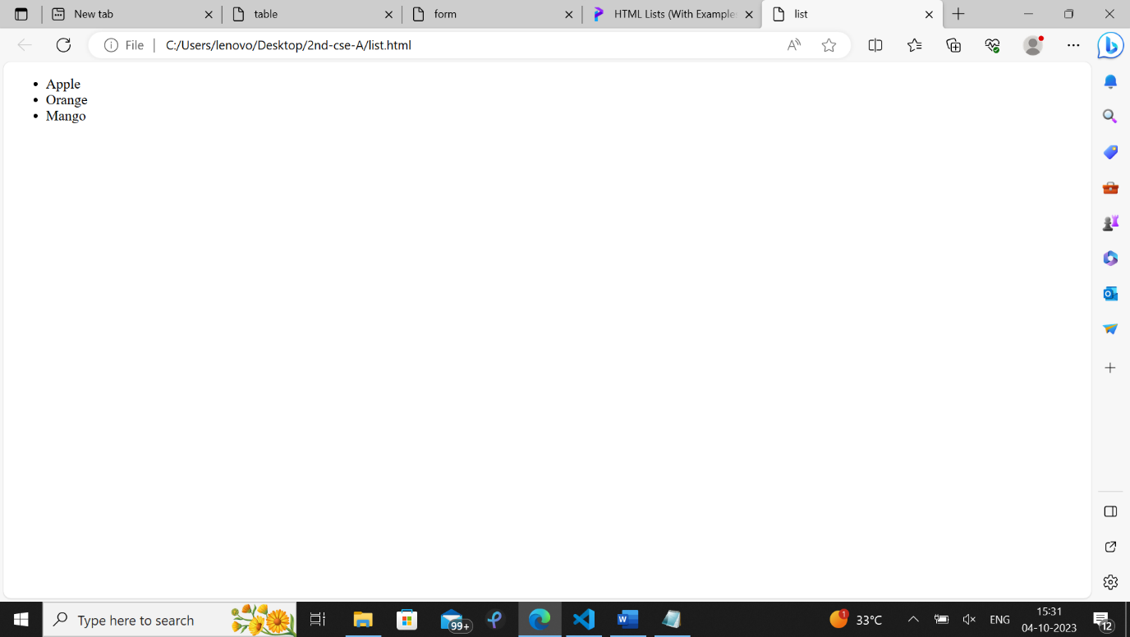

Ordered List

The ordered list is used to represent data in a list for which the order of items has significance.

<!DOCTYPE html>

<html>

<head>

<title> list</title>

</head>

<body>

<ol>

<li>Apple</li>

<li>Orange</li>

<li>Mango</li>

</ol>

</body>

</html>

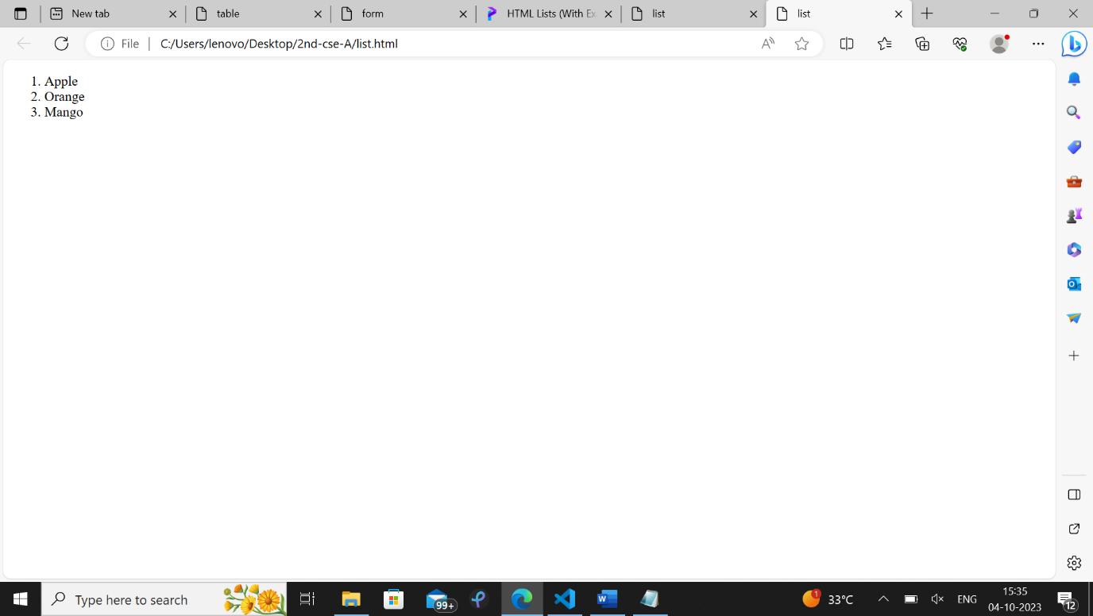

The HTML table tag (<table>) is used to create table

<!Doctype html>

<html>

<head>

<title>table</title>

</head>

<body>

<table border="1" >

<tr> <th>Name</th> <th>Age</th> <th>Country</th> </tr>

<tr> <td>Harry Depp</td> <td>28</td> <td>Britain</td> </tr>

<tr> <td>John Smith</td> <td>35</td> <td>USA</td> </tr>

<tr> <td>Ram Krishna</td> <td>19</td> <td>Nepal</td> </tr>

</table>

</body>

</html>

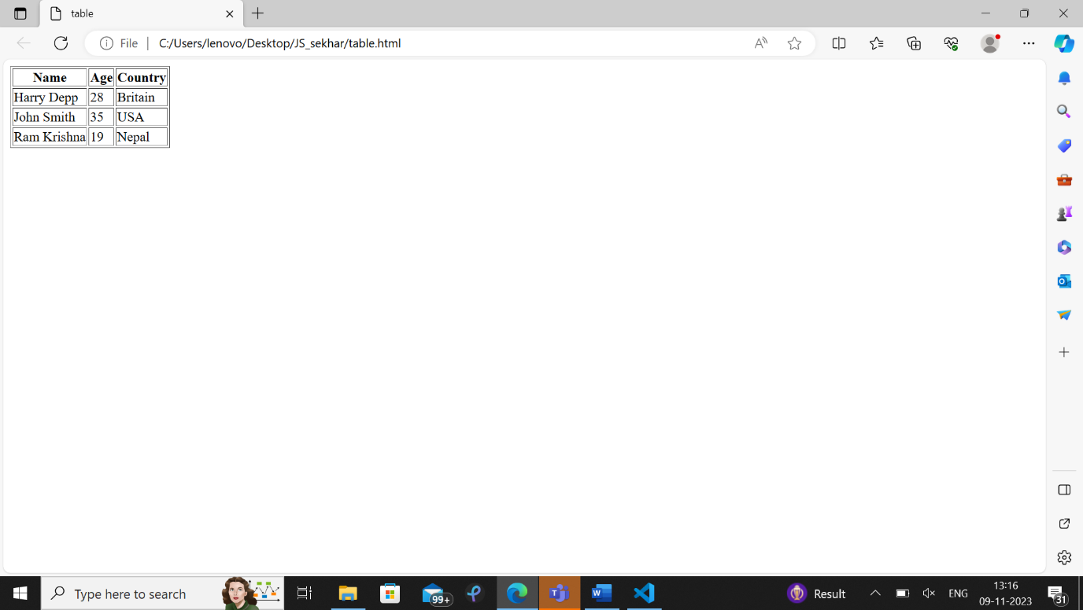

Creating Registration form

An HTML Form is a section of the document that collects input from the user. The input from the user is generally sent to a server

<!DOCTYPE html>

<html>

<head>

<title> form</title>

</head>

<body>

<h1>Registratoin form</h1>

<form>

<label for="firstname">First name: </label>

<input type="text" name="firstname" required><br><br>

<label for="lastname">Last name: </label>

<input type="text" name="lastname" required><br><br><br>

&nbsp&nbsp&nbsp&nbsp&nbsp&nbsp;<label for="email">email: </label>

<input type="email" name="email" required><br><br><br>

<label for="password">password: </label>

<input type="password" name="password" required><br><br><br>

<label for="sex">Sex:</label>

<input type="radio" name="sex" id="male" value="male">

<label for="male">Male</label>

<input type="radio" name="sex" id="female" value="female">

<label for="female">Female</label> <br><br>

<label for="country">Country: </label>

<select name="country" id="country">

<option>Select an option</option>

<option value="india">India</option>

<option value="usa">USA</option>

<option value="uk">UK</option>

</select><br><br><br><br>

<label for="message">Message:</label><br>

<textarea name="message" id="message" cols="30" rows="4"></textarea><br><br>

<label for="newsletter">Subscribe?</label><br><br>

<input type="submit" value="Submit">

</form>

</body>

</html>

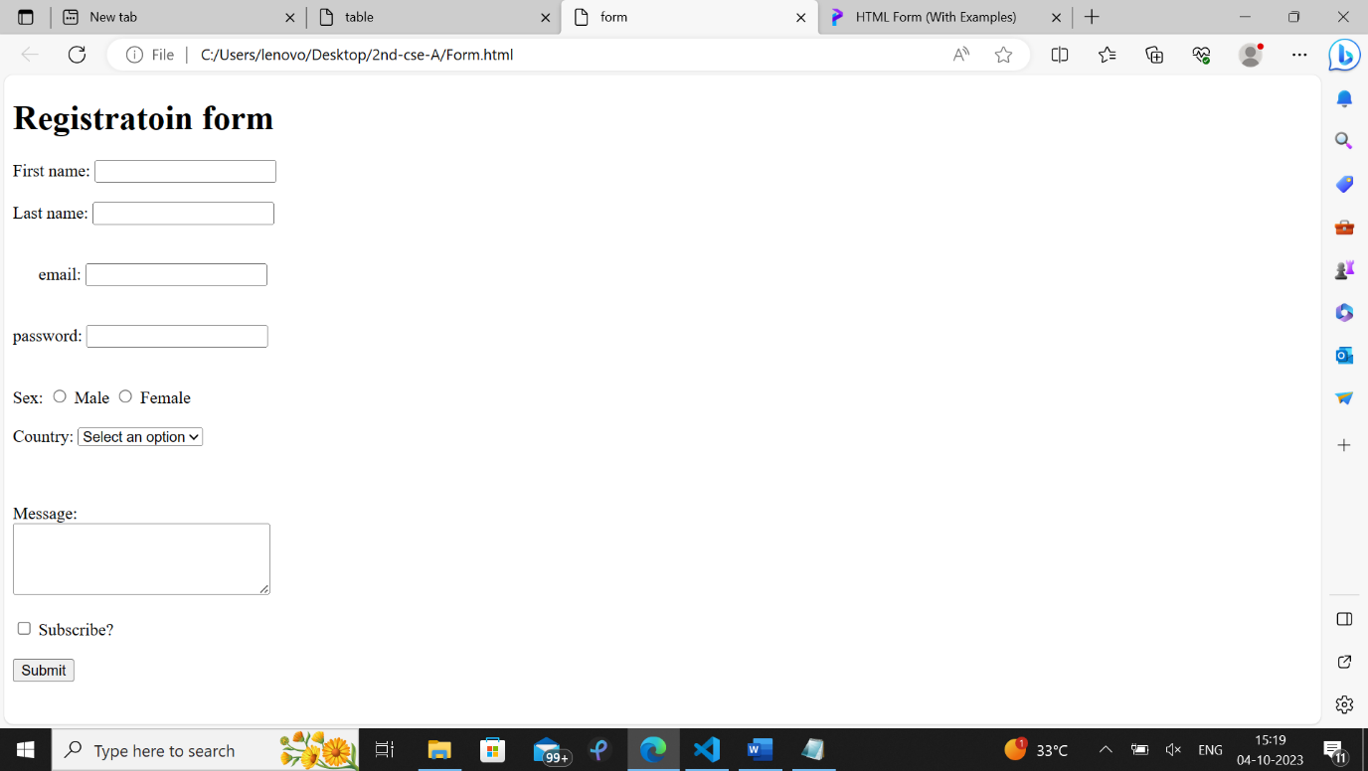

HTML Links

<a href=” path of the web page to go”> </a>

Links are found in nearly all web pages. Links allow users to click their way from page to page.

HTML links are hyperlinks.

You can click on a link and jump to another document.

<!Doctype html>

<html>

<head>

<title>Links </title>

</head>

<body>

<ul>

<li><a href="div1.html">click go to Div page</a></li>

<li><a href="image.html">click to go to image</a></li>

</ul>

</body>

</html>

Output:

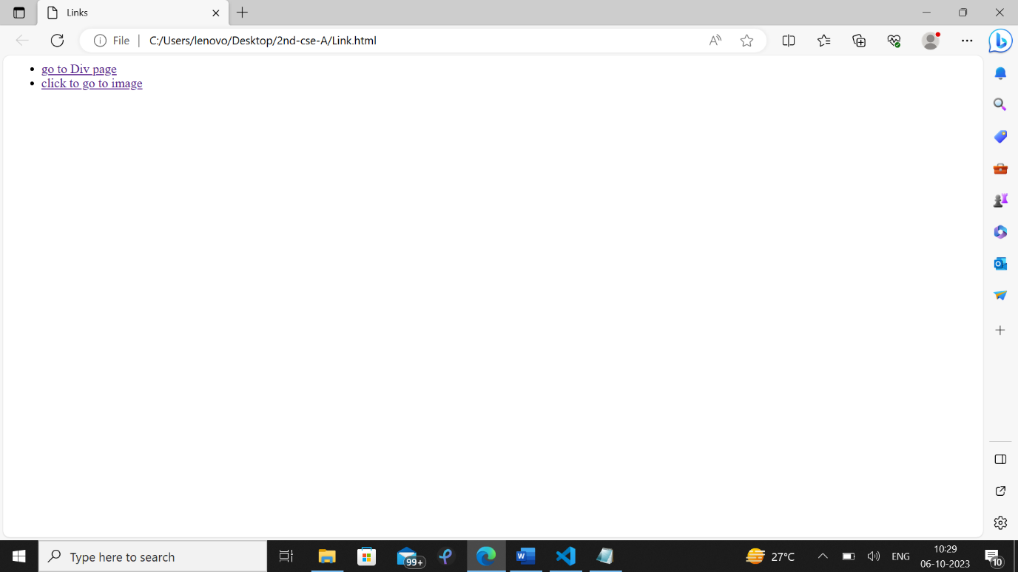

s

Image display on web page

<!Doctype html>

<html>

<head>

<title> image reation</title>

</head>

<body

<img src="C:\Users\lenovo\Desktop\cse-C\flower1.JPG" width=200px height=300px>

</body>

</html>

Output:

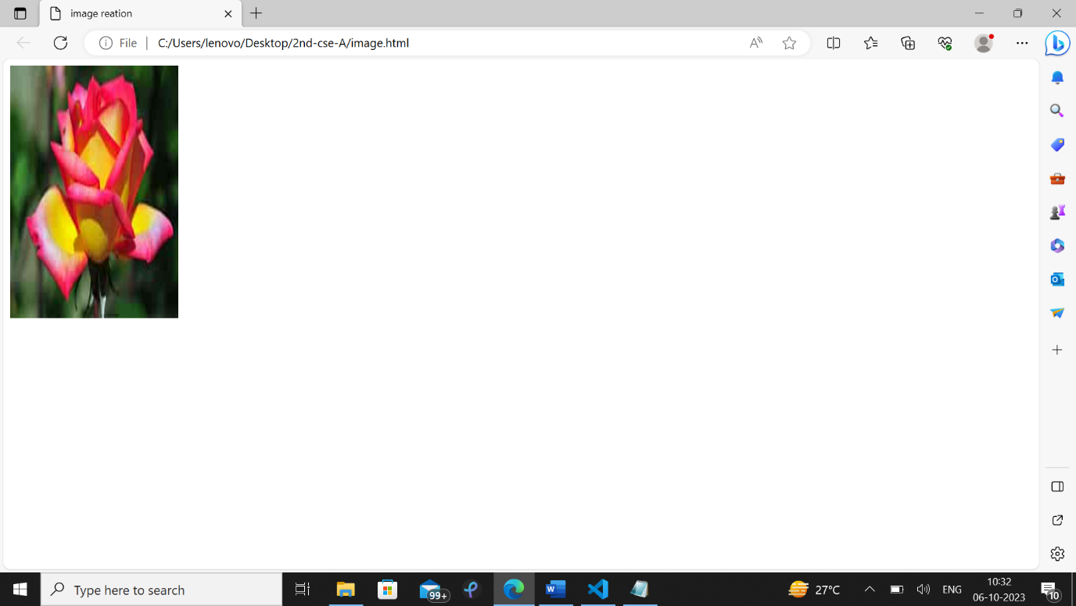

**Partitioning Web page into parts with Div tag**

<div> tag used to divide web page into parts , vertically or horizontally

<!DOCTYPE html>

<html>

<head>

<title> divison </title>

<style>

.div1 {

color: red;

border: 1px solid red;

}

.div2 {

color: green;

background-color: yellow;

border: 2px solid black;

}

</style>

</head>

<body>

<div class="div1">

<h2>This is heading.</h2>

<p>This is a paragraph</p>

</div>

<div class="div2">

<h2>This is another heading.</h2>

<p>This is another paragraph</p>

</div>

</body>

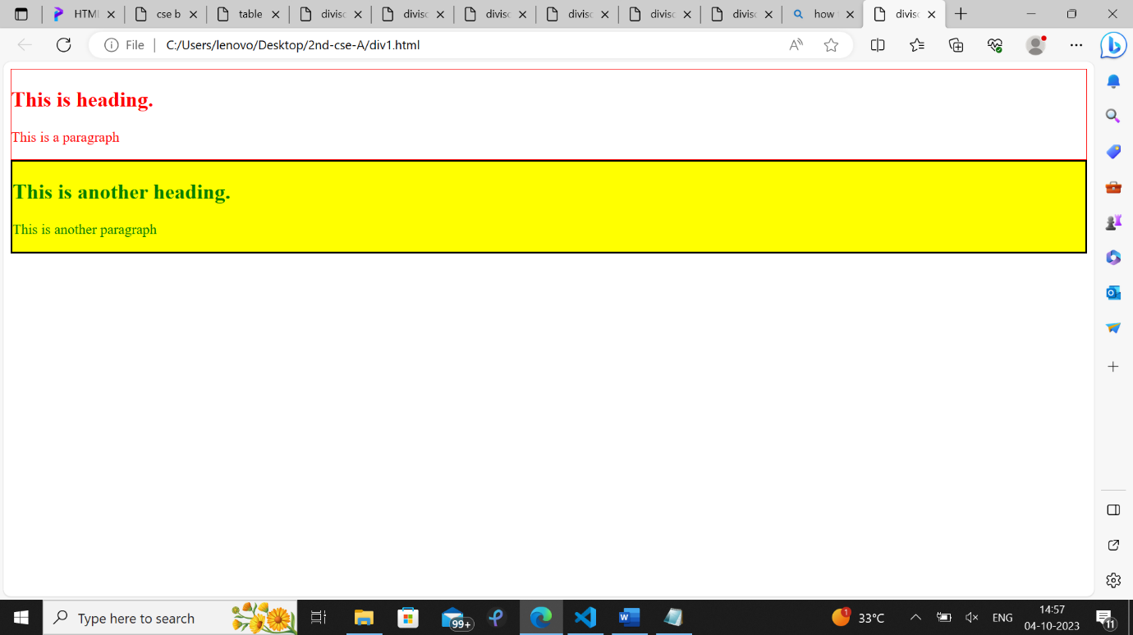

Example of the inline CSS:

<!DOCTYPE html>

<html>

<head>

<title>Title of the document</title>

</head>

<body>

<h1>Usage of the inline CSS</h1>

<p style="color:red;">The paragraph is red.</p>

</body>

</html>

Output:

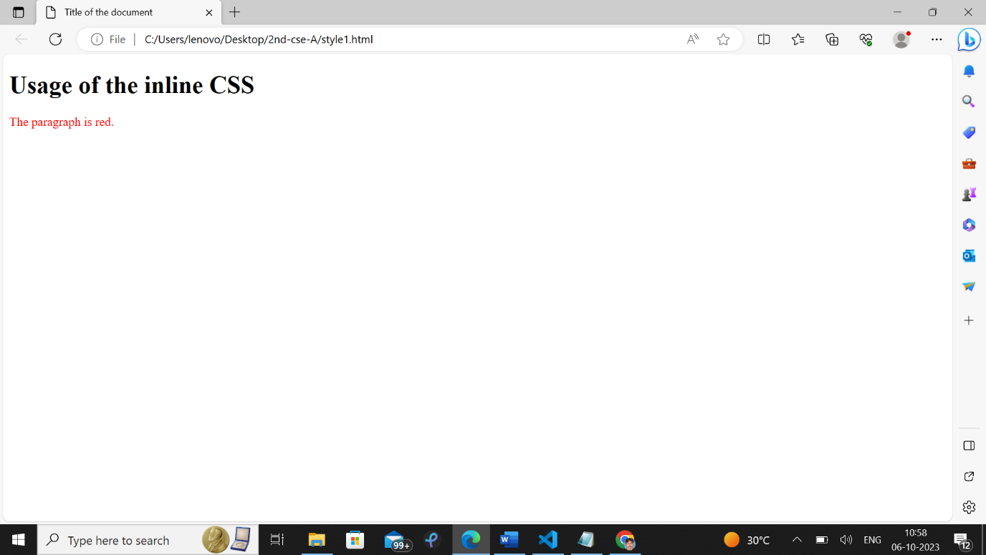

Example of the internal CSS:

<!DOCTYPE html>

<html>

<head>

<title>Title of the document</title>

<style>

body {

background-color: yellow;

}

h1 {

font-size: 30px;

}

p {

font-size: 18px;

}

</style>

</head>

<body>

<h1>Lorem Ipsum</h1>

<p>

Lorem ipsum, or lipsum as it is sometimes known, is dummy text used in laying out print, graphic or web designs. The passage is attributed to an unknown typesetter in the 15th century who is thought to have scrambled parts of Cicero's De Finibus Bonorum et Malorum for use in a type specimen book.

</p>

</body>

</html>

Output:

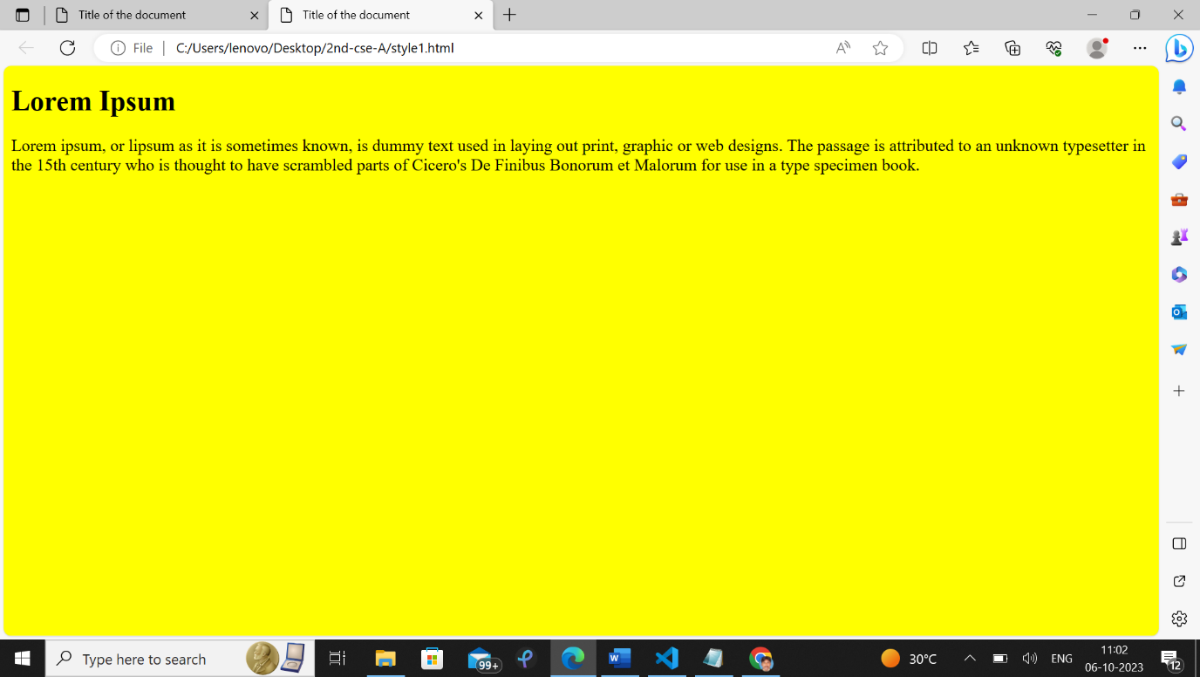

Example of the external CSS sheet:

<!DOCTYPE html>

<html>

<head>

<title>Title of the document</title>

<link rel="stylesheet" href="styles.css">

</head>

<body>

<h1>Lorem Ipsum</h1>

<p>

Lorem ipsum, or lipsum as it is sometimes known, is dummy text used in laying out print, graphic or web designs. The passage is attributed to an unknown typesetter in the 15th century who is thought to have scrambled parts of Cicero's De Finibus Bonorum et Malorum for use in a type specimen book.

</p>

</body>

</html>

Output:

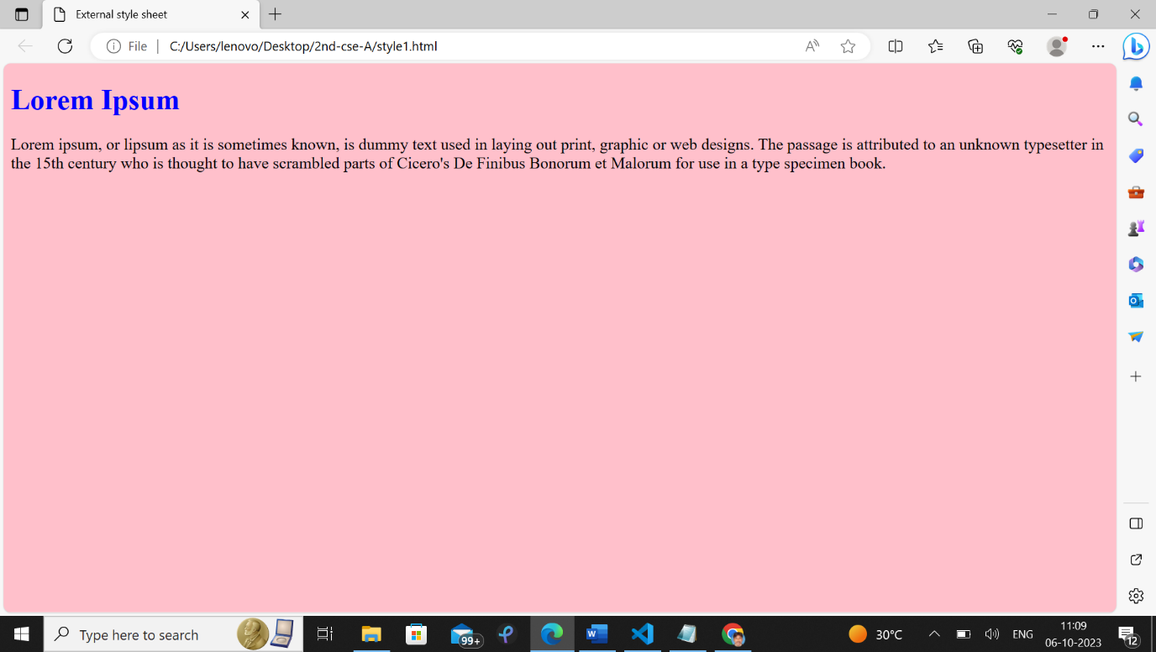

**Table creation using Bootstrap**

<!DOCTYPE html>

<html>

<head>

<meta charset="utf-8">

<meta name="viewport" content="width=device-width, initial-scale=1, maximum-scale=2, minimum-scale=1">

<!-- Bootstrap CSS -->

<link rel="stylesheet" href="https://cdn.jsdelivr.net/npm/bootstrap@4.6.2/dist/css/bootstrap.min.css" integrity="sha384-xOolHFLEh07PJGoPkLv1IbcEPTNtaed2xpHsD9ESMhqIYd0nLMwNLD69Npy4HI+N" crossorigin="anonymous">

<!-- jQuery library -->

<script src="https://cdn.jsdelivr.net/npm/jquery@3.5.1/dist/jquery.slim.min.js" integrity="sha384-DfXdz2htPH0lsSSs5nCTpuj/zy4C+OGpamoFVy38MVBnE+IbbVYUew+OrCXaRkfj" crossorigin="anonymous"></script>

<!-- Latest compiled Bootstrap JS-->

<script src="https://cdn.jsdelivr.net/npm/bootstrap@4.6.2/dist/js/bootstrap.bundle.min.js" integrity="sha384-Fy6S3B9q64WdZWQUiU+q4/2Lc9npb8tCaSX9FK7E8HnRr0Jz8D6OP9dO5Vg3Q9ct" crossorigin="anonymous"></script>

</head>

<body>

<div class="container mt-3">

<table class="table-primary>

<thead>

<tr>

<th scope="col">#</th>

<th scope="col">First</th>

<th scope="col">Last</th>

<th scope="col">Handle</th>

</tr>

</thead>

<tbody>

<tr>

<th scope="row">1</th>

<td>Mark</td>

<td>Otto</td>

<td>@mdo</td>

</tr>

<tr>

<th scope="row">2</th>

<td>Jacob</td>

<td>Thornton</td>

<td>@fat</td>

</tr>

<tr>

<th scope="row">3</th>

<td colspan="2">Larry the Bird</td>

<td>@twitter</td>

</tr>

</tbody>

</table>

</div>

</body>

</html>

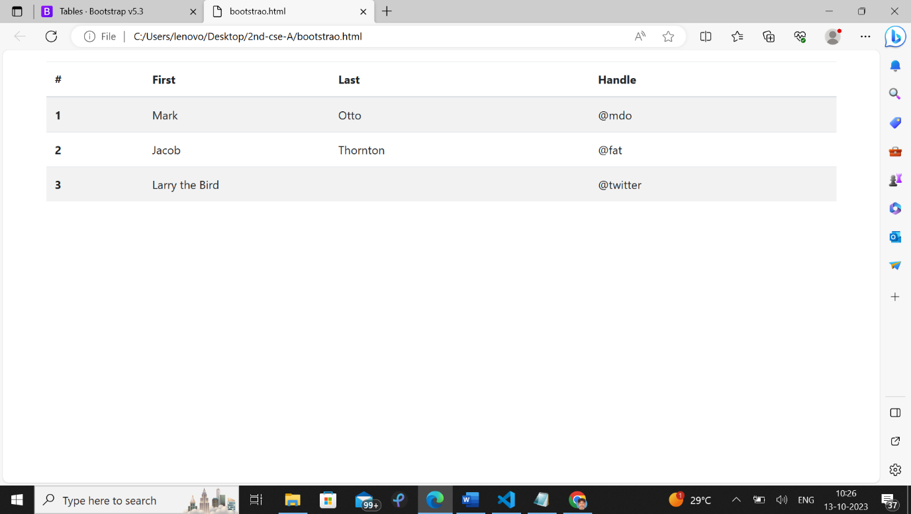

**Bootstrap Image display**

<!DOCTYPE html>

<html lang="en">

<head>

<title>Bootstrap Example</title>

<meta charset="utf-8">

<meta name="viewport" content="width=device-width, initial-scale=1">

<link href="https://cdn.jsdelivr.net/npm/bootstrap@5.3.2/dist/css/bootstrap.min.css" rel="stylesheet">

<script src="https://cdn.jsdelivr.net/npm/bootstrap@5.3.2/dist/js/bootstrap.bundle.min.js"></script>

</head>

<body>

<div class="container mt-3">

<h2>Circle</h2>

<p>The .rounded-circle class shapes the image to a circle:</p>

<img src="flower1.jpg" class="rounded-circle" alt="Cinque Terre" width="304" height="236">

</div>

</body>

</html>

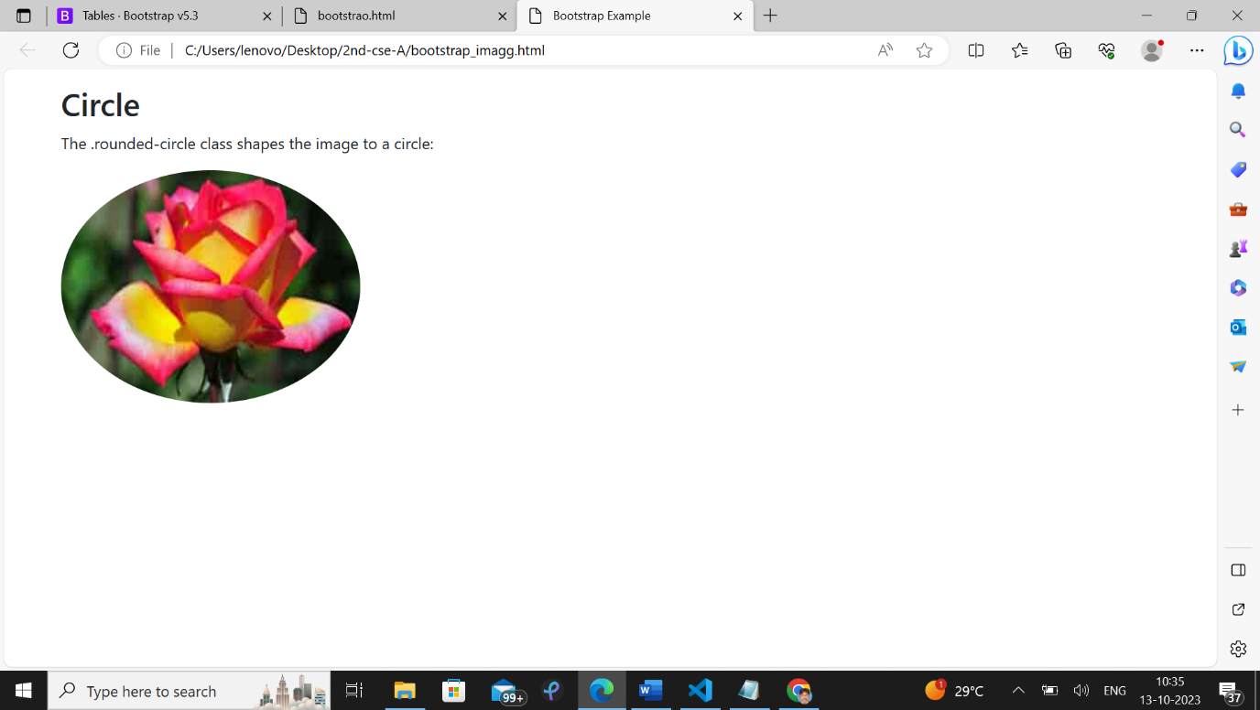

Javascript addition of two numbers program

<!Doctype html>

<head>

<head></head>

<title> javascript</title>

</head>

<body>

<h> Welcome to javascript</h><br>

<script>

let x=10;

let y=20;

let z=x+y;

let p=x-y;

document.write('the sum of x and y is '+z)

document.write("<br>");

document.write("difference of x and y is ",+p);

</script>

</body>

</html>

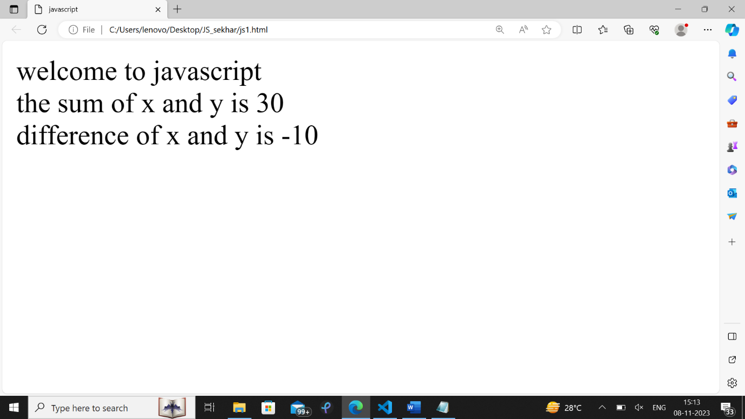

**Javascript Events**

<!DOCTYPE html>

<html>

<head><title> js validation</title>

</head>

<body>

<h>js validation</h>

<form name="f1" onsubmit="return validate()">

<table border="1">

<tr><td>Name</td><td><input type="text" name="n1"></td></tr>

<tr><td>Password</td><td><input type="password" name="pwd"></td></tr>

<tr><td><input type="submit" value="Submit"></td></tr>

</table>

</form>

<script type="text/javascript">

function validate()

{

var name=document.forms['f1']['n1'].value;

var pwd1=document.forms['f1']['pwd'].value;

if(name.length<6){

alert("name must be 6 characters");

return false;

}

else if(pwd1.length<6)

{

alert("password must be atleast 6 characters");

return false;

}

}

</script>

</body>

</html>

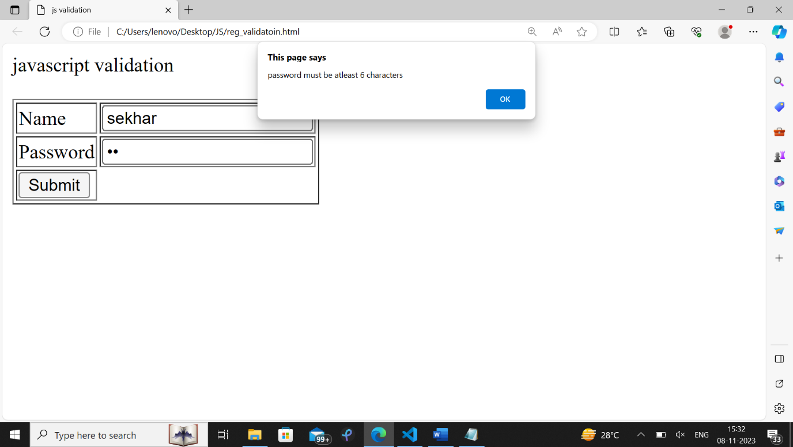

**Home page**

const Home=()=>{

return(

<>

<h>React JS</h>

<p>Welocme to React js.React js is ,Javascript framework.It is SPA</p>

</>

);

};

export default Home;

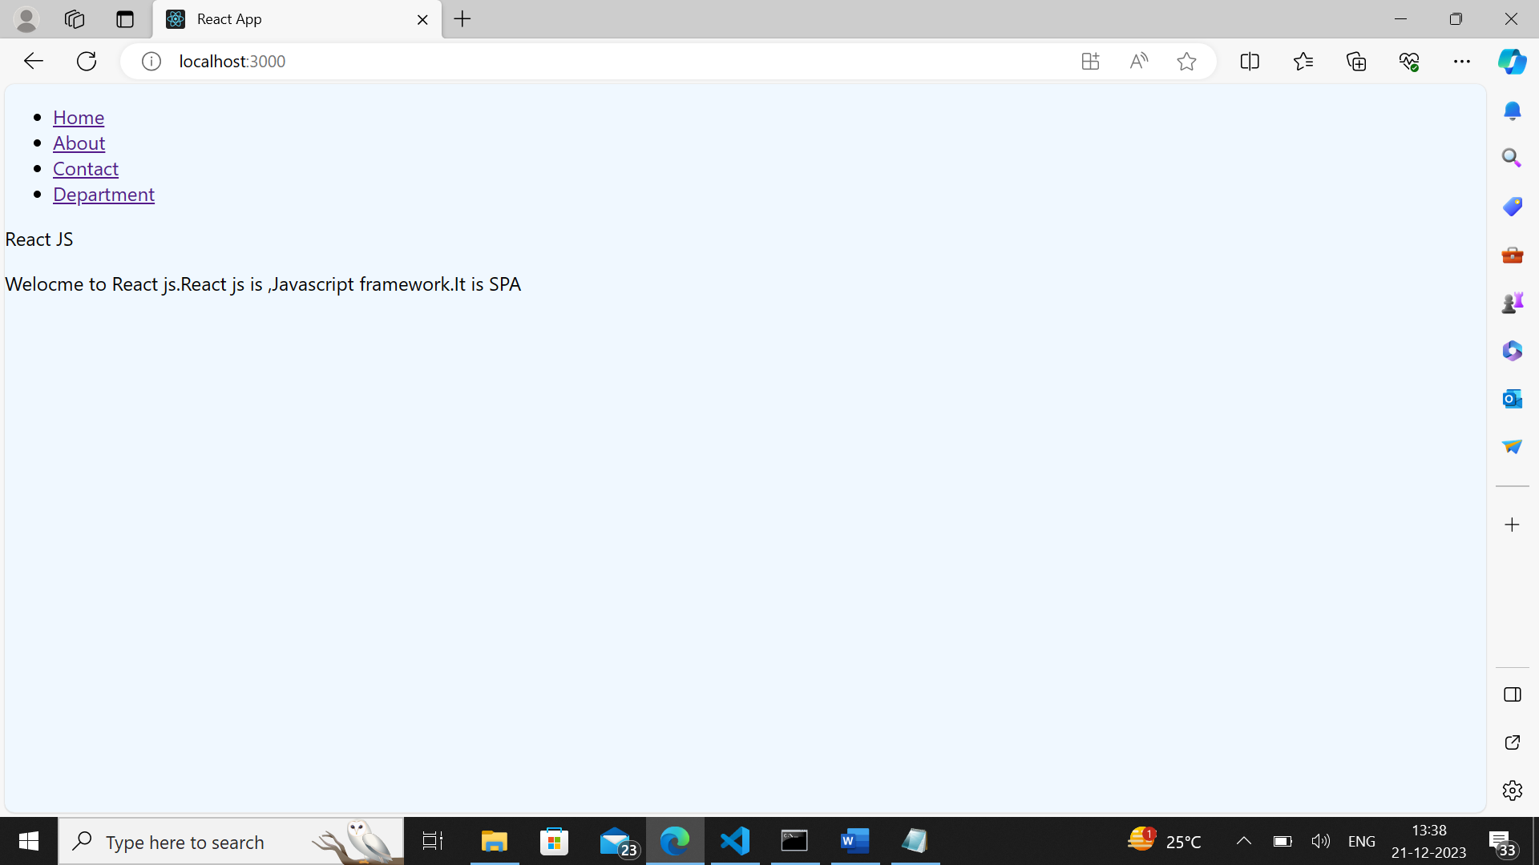

**About page**

const About=()=>{

return(

<>

<h>welcome to About page</h>

<table>

<tr><th>S NO</th><th>Name</th></tr>

<tr><td>123</td><td>Kamal</td></tr>

<tr><td>556</td><td>Vimal</td></tr>

</table>

</>

);

};

export default About;

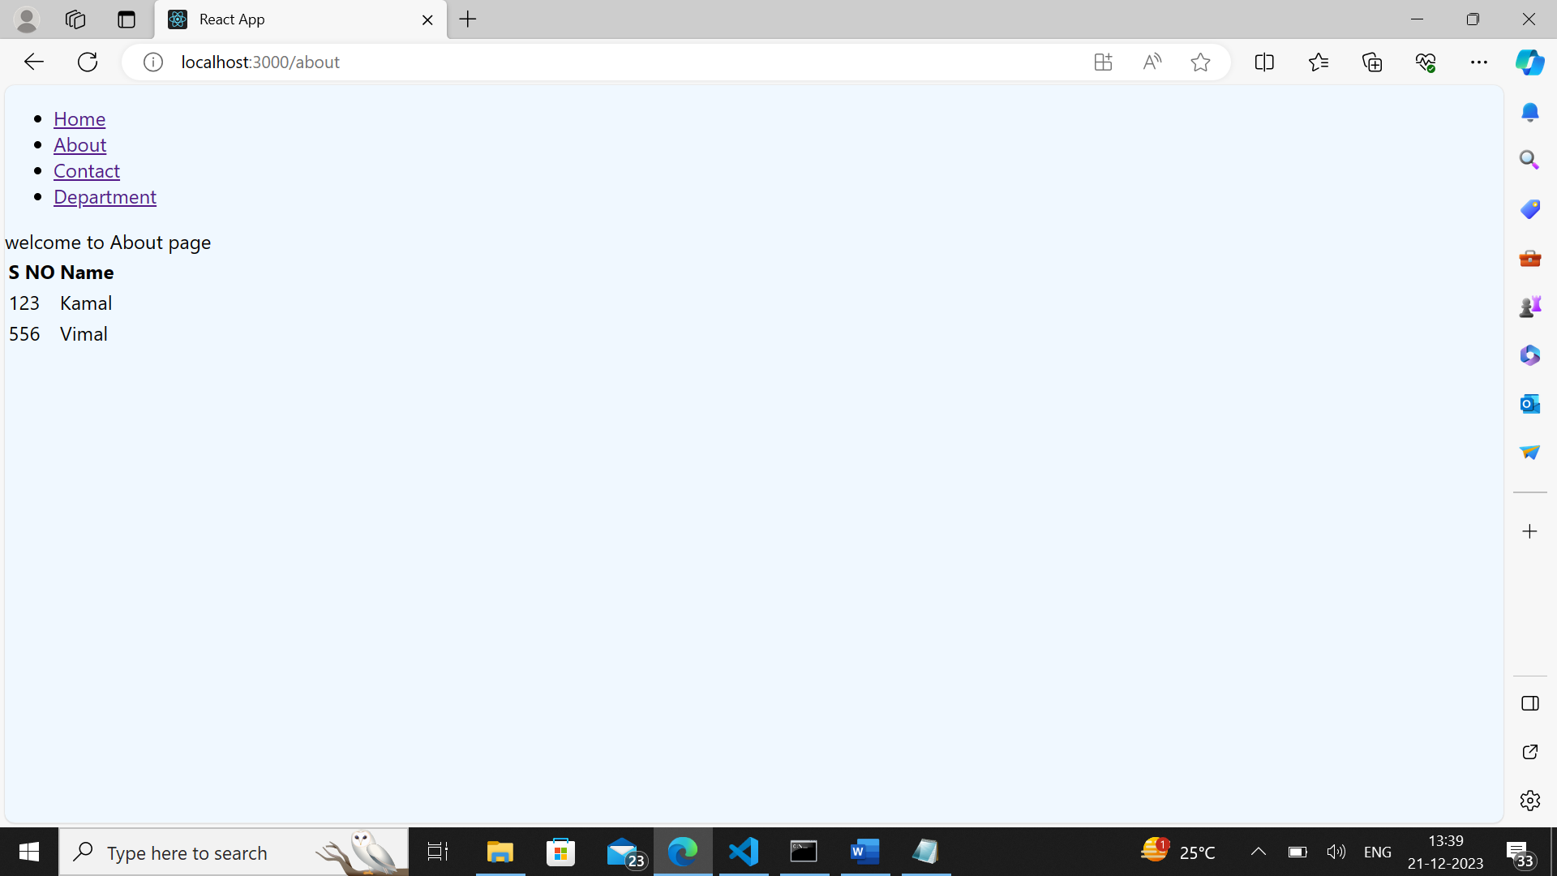

**Contact page**

import React from "react";

import pic from "./flower1.jpg";

const Contactt=()=>{

return(

<>

<h>welcome to About page</h><br />

<img src={pic}/>

</>

);

};

export default Contactt;

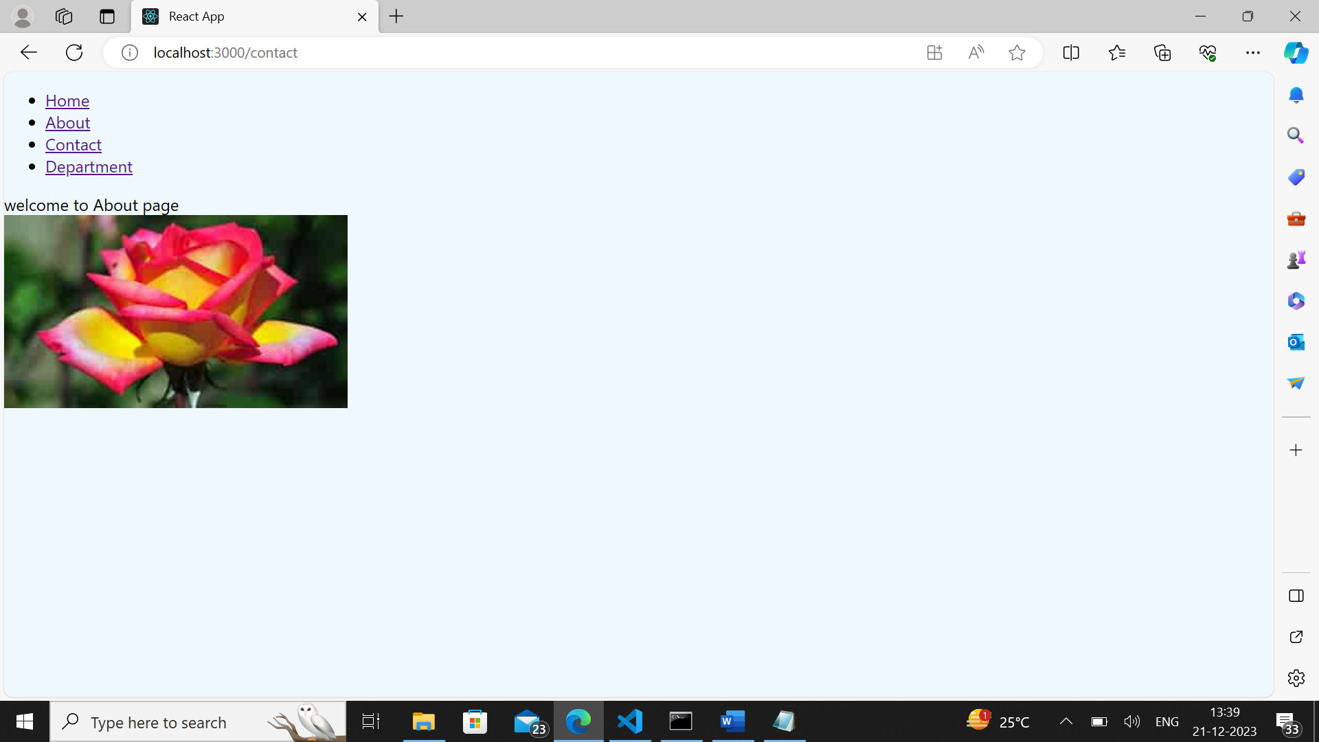

**Department page**

import React from "react";

const Department=()=>{

return(

<>

<ol>

<li>CSE</li>

<li>Mechanical</li>

<li>ECE</li>

</ol>

</>

);

};

export default Department;

